Name:  Teacher: | ___________________________________________  ___________________________ |  | Date:___________
 | Year 9 Mathematics  SCORE:  / 35  Topic – Trigonometry  Working out MUST BE SHOWN for full marks
Total Time: | 40 minutes
Weighting: | 6 %
Equipment: | To be provided by the student:  Pens and Pencils, scientific calculator, ruler and an A4 page of notes.

Multiple choice questions 6 marks

Question 1. Which statement is true for the angle θ in the diagram?  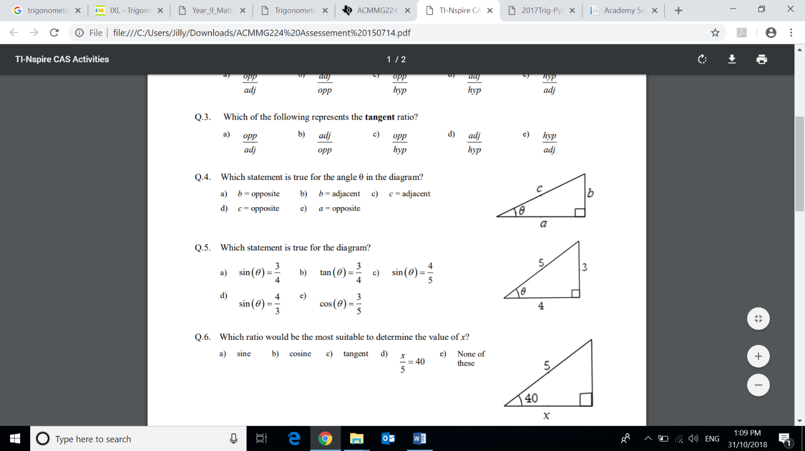  - b = opposite  - b = adjacent  - c = adjacent  - a = opposite | Question 2. What is the length of the adjacent side when considering the 20$°$ angle?  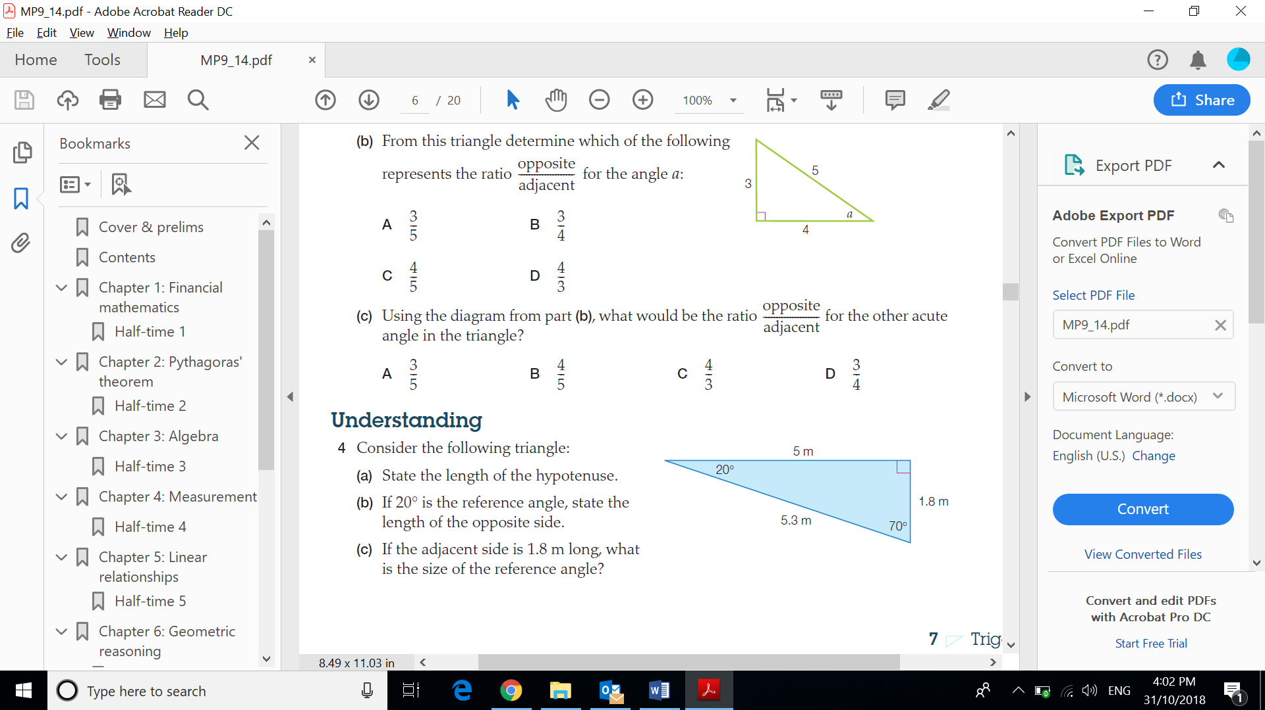  - 20 m  - 5 m  - 1.8 m  - 5.3 m
Question 3. What is the ratio for Sine?  - $\frac{HYP}{OPP}$  - $\frac{OPP}{ADJ}$  - $\frac{OPP}{HYP}$  - $\frac{ADJ}{OPP}$ | 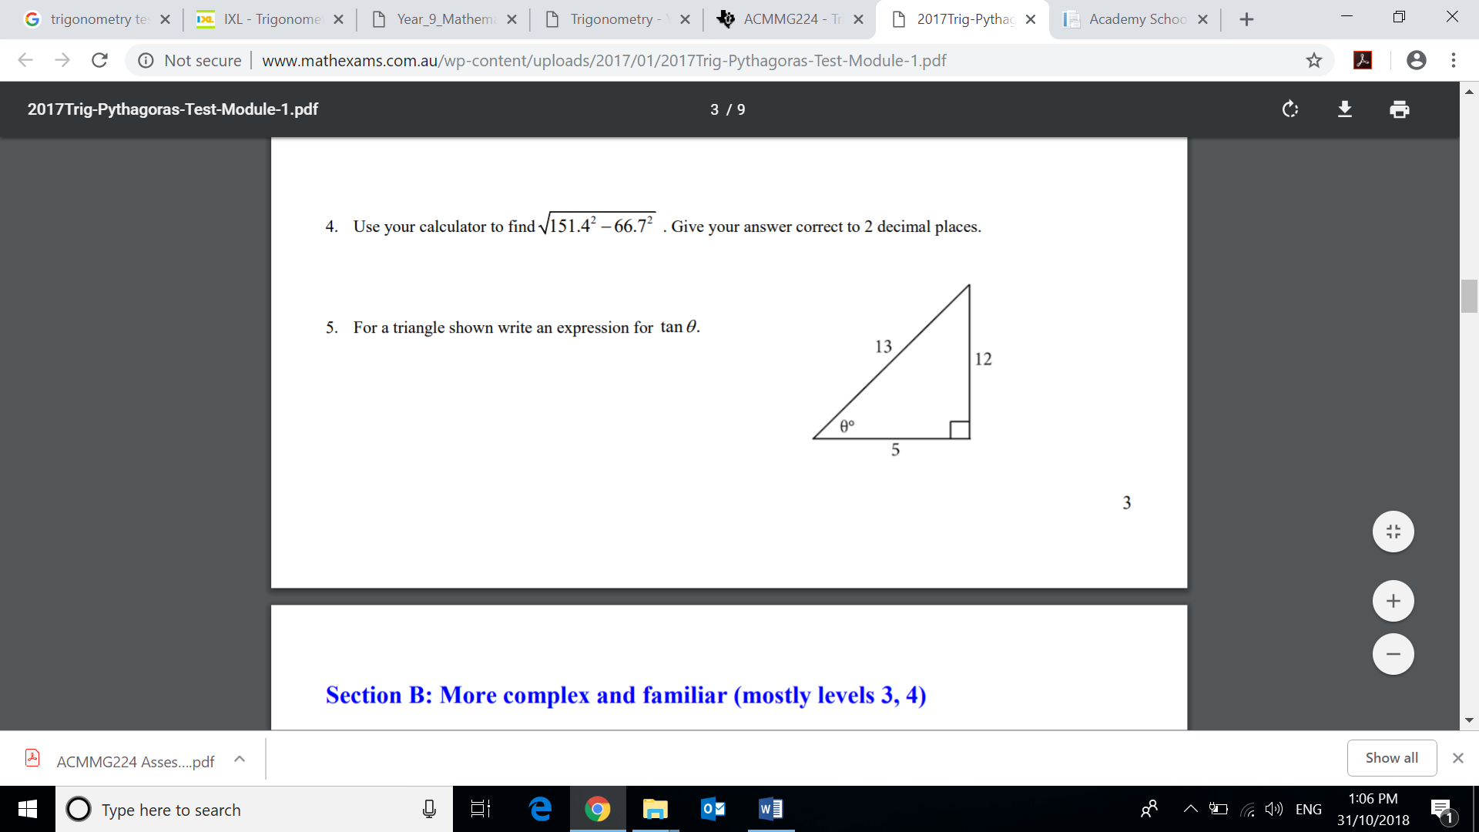  Question 4. Which is the correct ratio for $\tan{θ}$  - $\frac{13}{12}$  - $\frac{5}{12}$  - $\frac{5}{13}$  - $\frac{12}{5}$
  Question 5. Which statement is true for the diagram?  - $\sin{θ= \frac{3}{4}}$  - $\tan{θ= \frac{3}{4}}$  - $\sin{θ= \frac{4}{5}}$  - $\sin{θ= \frac{4}{3}}$ | Question 6. Which ratio would you use to determine the value of x?  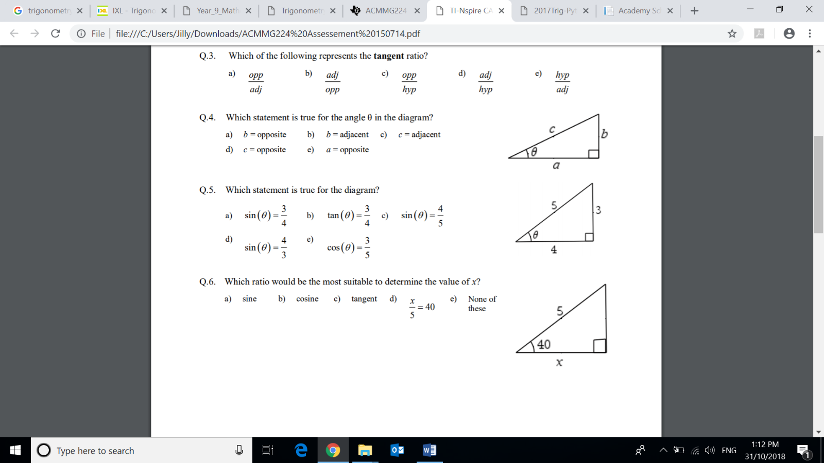  - sine  - cosine  - tangent  - $\frac{x}{5}=40$
Short answer questions 29 marks
Show FULL working out to get FULL marks

Question 7. Calculate the lengths of the sides marked with letters in each of the following triangles, giving your answers to 3 decimal places. [8 marks]

a.  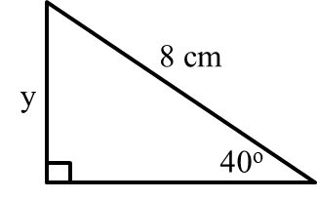 | b.  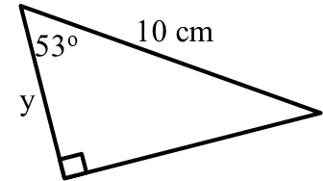
c.  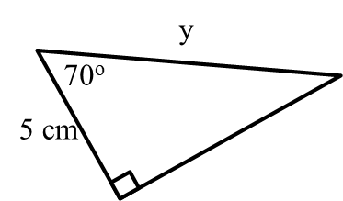 | d.  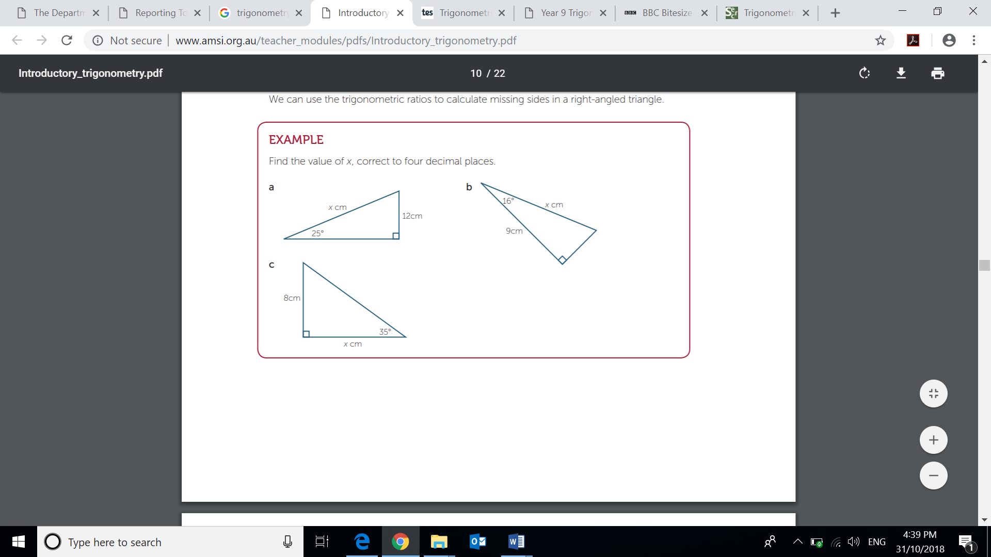

Question 8. Calculate the size of each of the angles marked θ in the following triangles, giving your answers to the nearest degree. [4 marks]

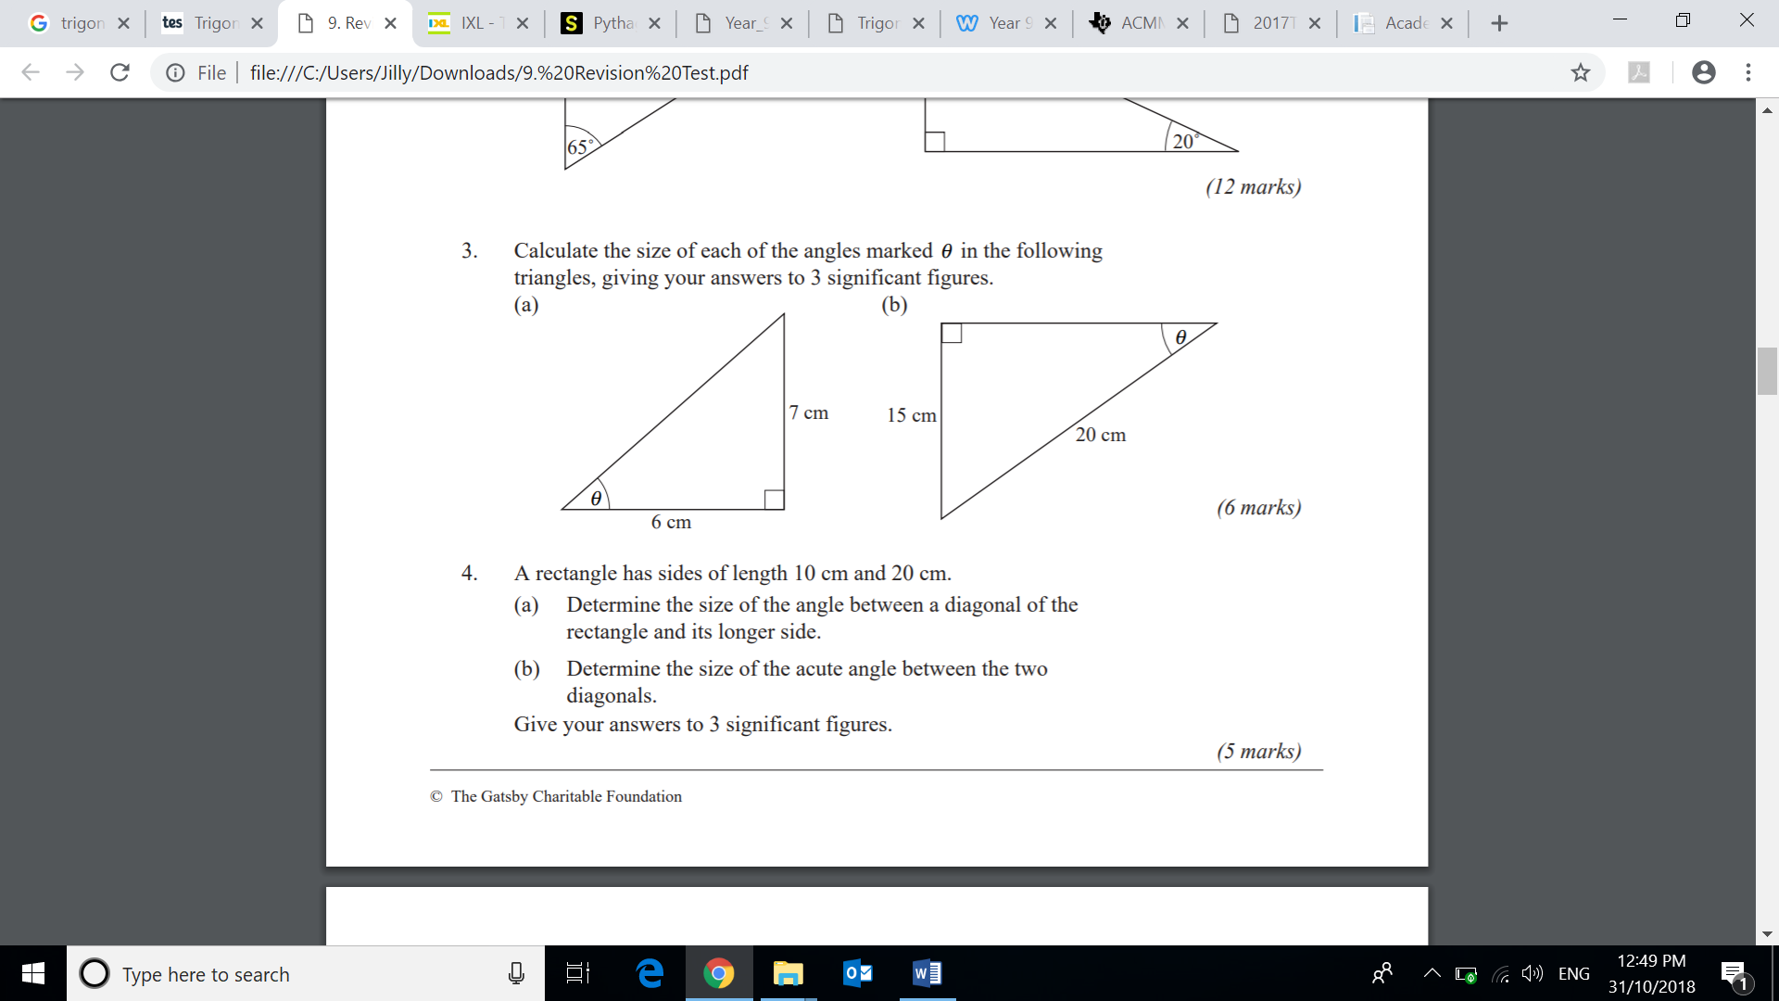 | 
Question 9. For the triangle shown, calculate the length of CD and AD. Give your answers to 2 decimal places. [4 marks]

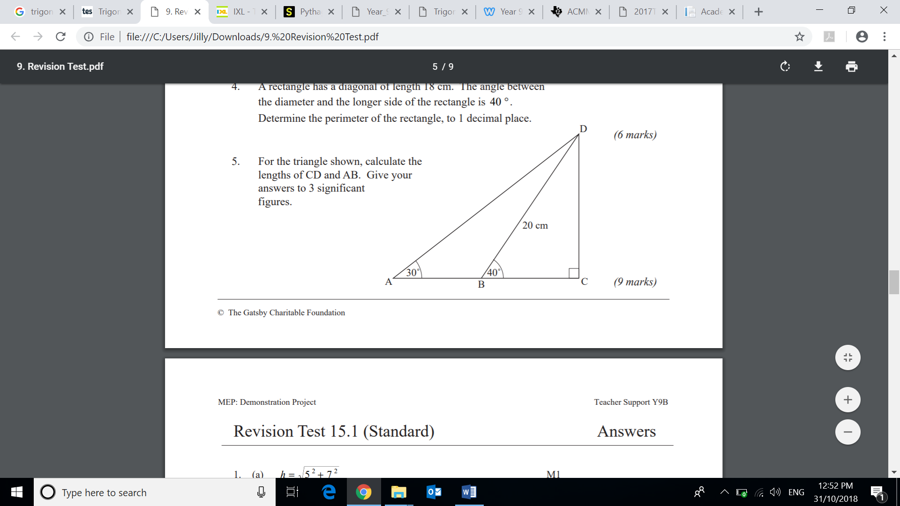

Question 10. A ladder of length 3 m makes an angle of 32° with the wall. [4 marks]

- Draw a diagram and label the given values.

- How far is the base of the ladder from the wall?

- What angle does the ladder make with the ground?

Question 11. The beam of a seesaw is 3.6 m long. When one end is on the ground it makes an angle of 17º with the ground. How high is the other end off the ground? [3 Marks]

Question 12. The following answers were given on a trigonometry test. [6 marks]

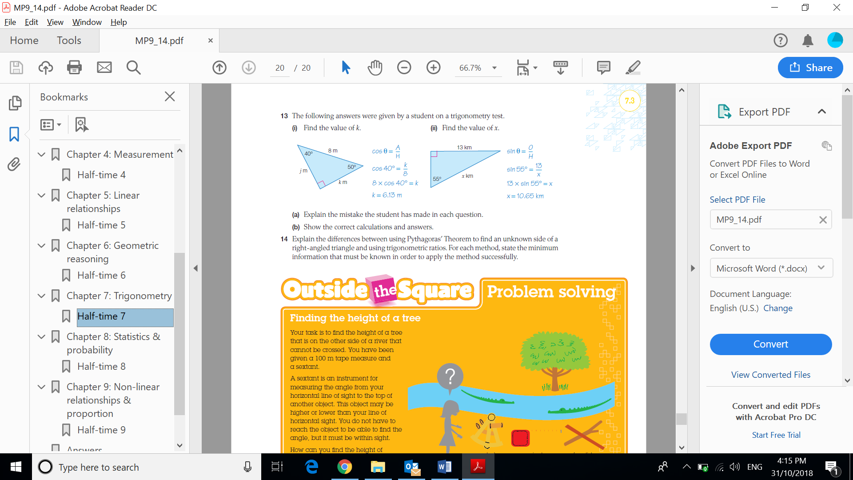 | 
a. What mistake did this student make? | a. What mistake did this student make?
b. Show the correct calculations and answers for the question above | b. Show the correct calculations and answers for the question above

END OF TEST

